

Java-project

**Java Supermarket management software**

**Supermarket**

(Non-Governmental Organization)

|  |  |
| --- | --- |
| **Authors** | **C2009I1 - Group 2** |
| TRAN MINH HUY - Student1276613 (Leader)  TRAN NHAN HAU - Student1276416  DUONG NGUYEN TAN DUC - Student1276677 |
| **Centre Name** | Aprotrain Aptech |
| **Date** | 10nd ,September 2021 |
| **Semester** | 2 |
| **Instructor** | KHIEM BUI DUY |

**HCM City, 10nd September 2021**

# Table of contents:

**Introduce Java-Project - Supermaket** 1

**Problem definition of project:** 2

**List of inputs to the Website:** 3

**List of Outputs Expected from the Website:** 4

**Overview of Processes Involved in the Website:** 5

**Hardware and Software Required for Implementing the Project:** 6

**Eclipse IDE and MySQL** 7

**Chart of sales status for the year** 8

**Table assigning tasks to members (Leader):** 9

**Instruction to run the project** 10

**1.** **Import database and tables into MySQL..** 11

**2.** **Import Project into Eclipse IDE..** 12

**3. Using Entity Framework to generate tables in MySQL** 13

**4.** **Run Software Application (Manager section)..** 14

A. Login Page 15

B. Software Type: 16

C. Sign In/Register/Personal Information: 17

D. Dashboard: 18

E. Product: 19

F. Category: 20

G. Brand: 21

H. Title: 22

I. Bill management: 23

J. Shift change management: 24

K. Warehouse management: 25

I. Expiration date management:: 26

I. Manage changes to employee account information: 27

**5.** **Run Software Application (Employee Section)..** 28

1. Login Page: 29
2. Sign In/Personal Information: 30
3. Bill Fee: 31
4. Inventory: Checking and making import slips 33
5. Bill management: 33
6. Change Shift: 34
7. Roll Call: 35

**6.** **Database.** 36

**Introduce Java-Project - Supermaket**

## **Problem definition of project:**

The Software is designed with the aim to help the needy. These Supermaket will take part in various welfare activities for raising funds to help the needy. The Software must flash the details of all the activities or the events which are going to happen or conducted. The GIVE-AID has been established with the help of many major companies contributions. Users can see and navigate the content of the software and also can register their account and choose the donation with concerned specified. Also they can ask others to join by sending mail to their respective ID’s.

## **List of inputs to the Software:**

* Manager:
* Login.
* Register employee.
* Create/Read/Update/Delete(CRUD) Category(person), Partner.
* Manage contents of employee.
* Employee:
* Login.
* Send gmail to another employee to change shift.
* Sales and product code scanning.

### **List of Outputs Expected from the Software:**

* Manager:
* Show list of Category,Brand,Title, Partner.
* Show contents of Product, Ware house.
* Show all registered employee information.
* Show sales, value, quality, best-selling products in a year.
* Show registered suppliers to import goods.
* Employee:
* Display a list of product links include: upcoming, ongoing, ended.
* Show sales, value, quality, best-selling products in a year.
* Display a list of products that the supermarket has deployed.

### **Overview of Processes Involved in the Software:**

* Manage Category,Brand,Title, Partner.
* Manage contents of Employee ,Product, Ware house Program.
* Manage images about programmes.
* Register, Login.

### **Hardware and Software Required for Implementing the Project:**

* Hardware:
  + 64 Megabytes of RAM or better.
  + Windows 98 or higher.
* Software:
  + Eclipse IDE.
  + MySQL all version.

### **Table assigning tasks to members (Leader):**

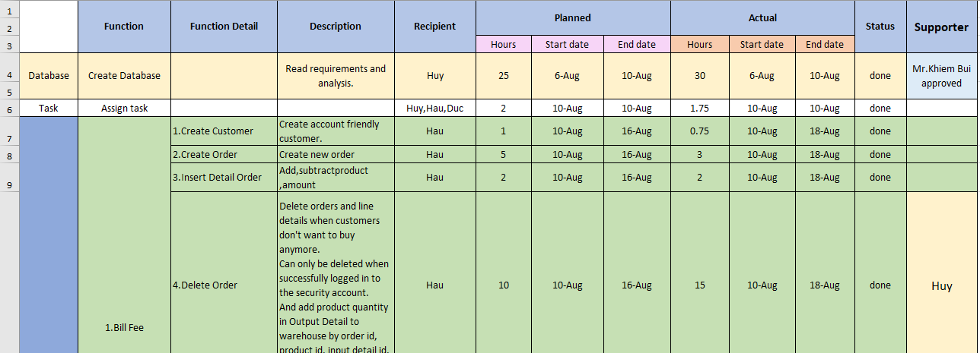

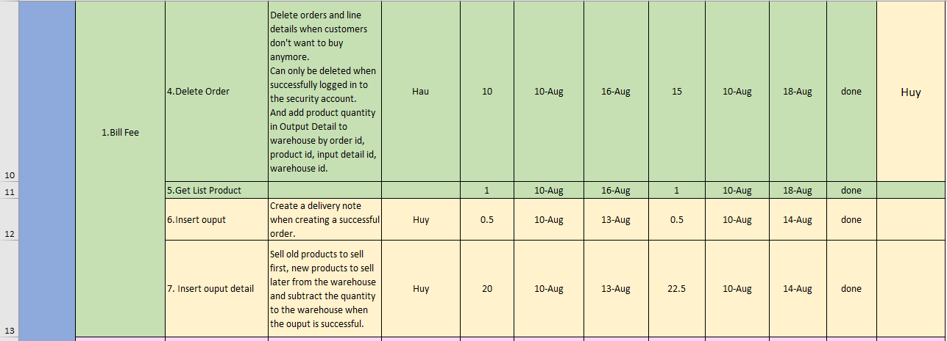

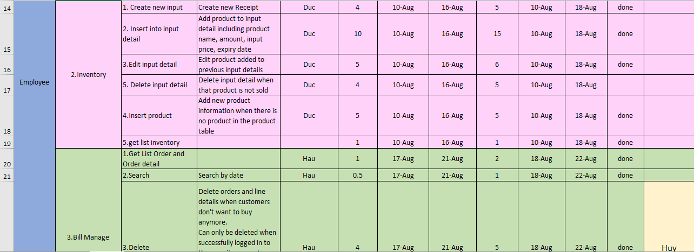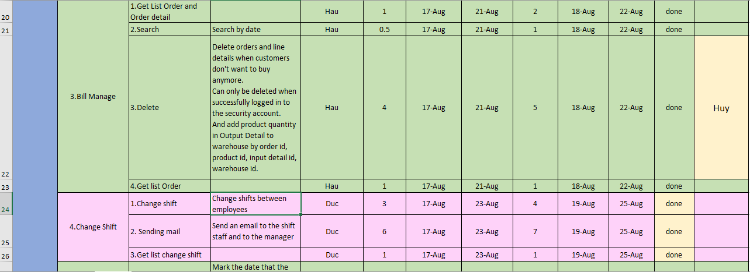

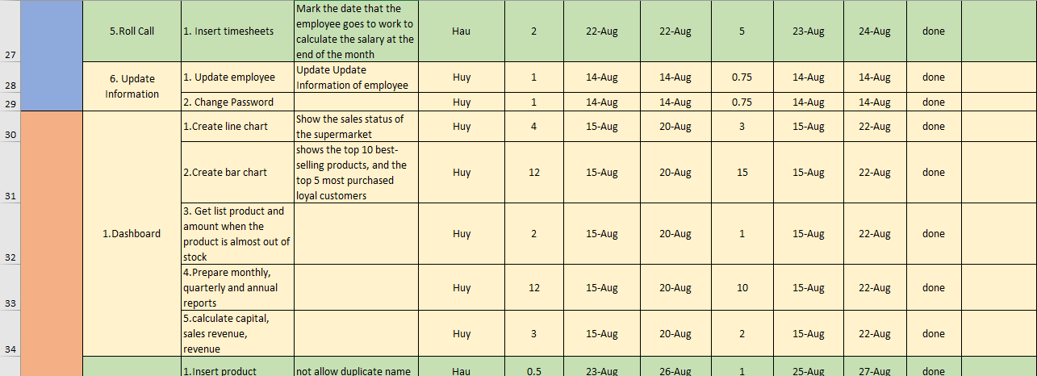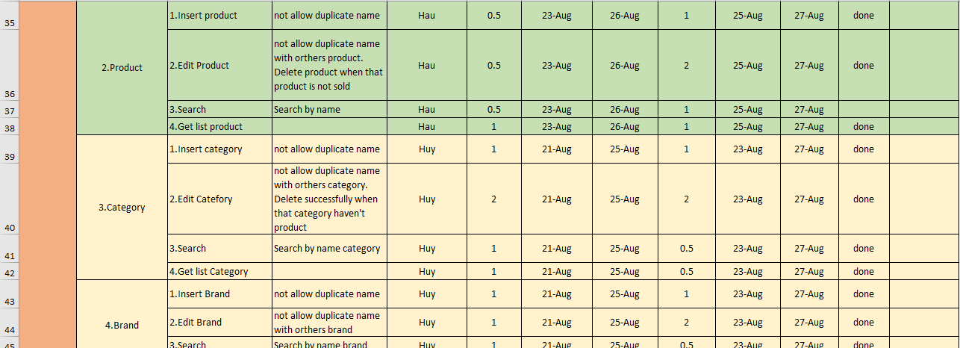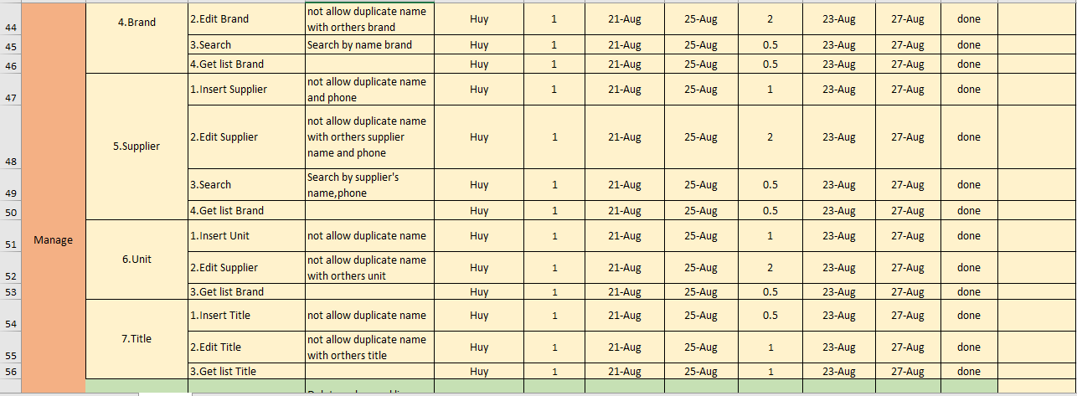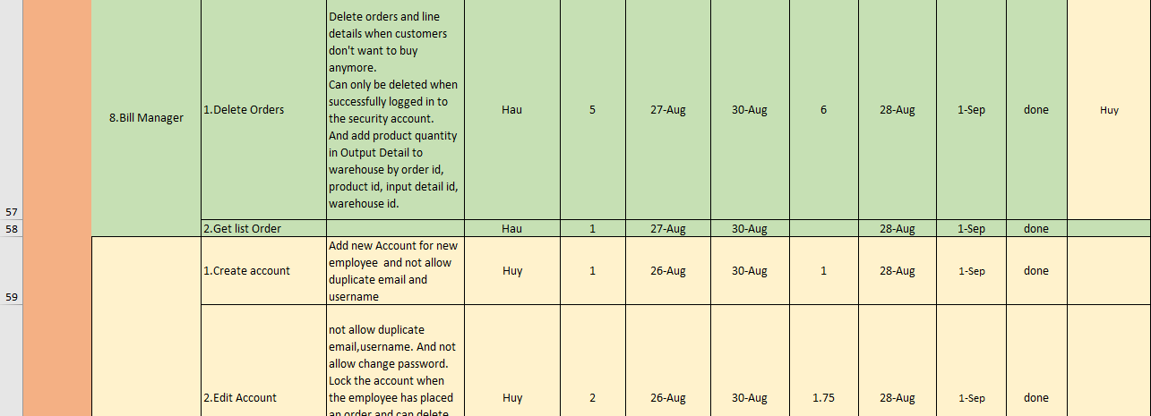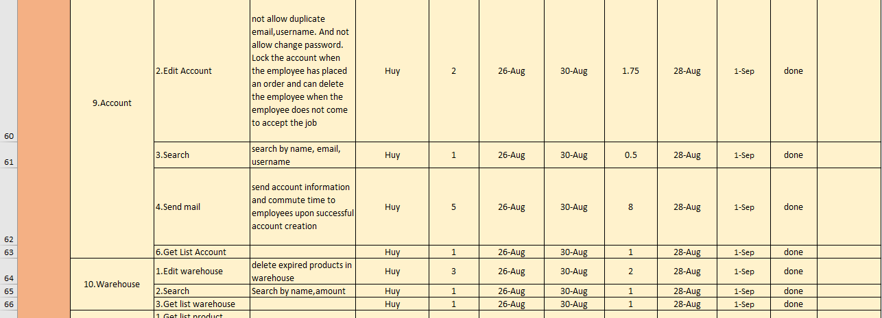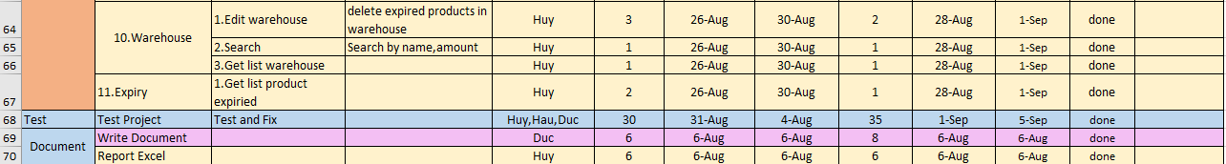

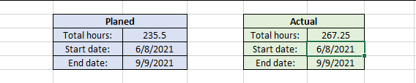

**➔NOTE:** *Please make sure your PC or laptop is connected to the Internet because I have imported the CDN in this project.*

# **Instruction to run the project**

* 1. **Import database and tables into MySQL.**

- *You import qlst.sql file that I sent into MySQL*. It looks like this:

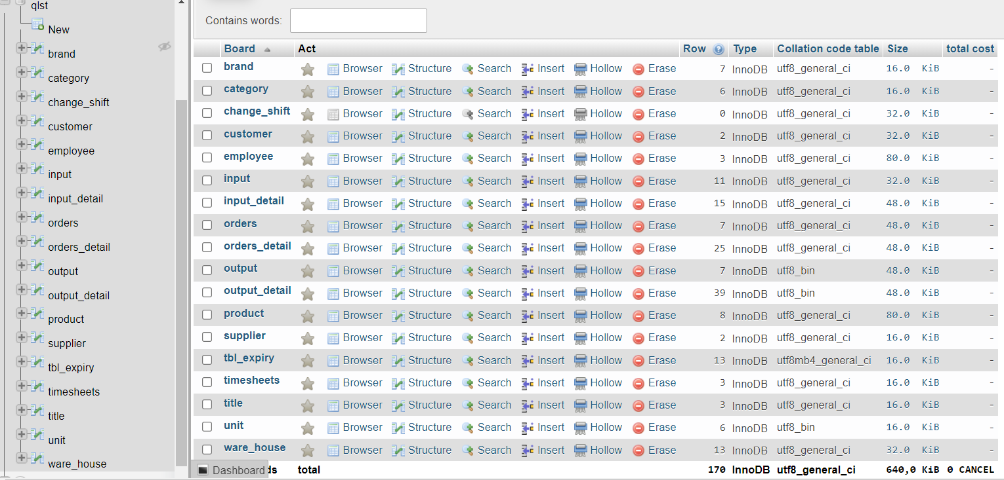

- Next, you go to the trap section on the database and check the constraints and trigger as shown in the figure.

- If it is complete, it means everything is successful:

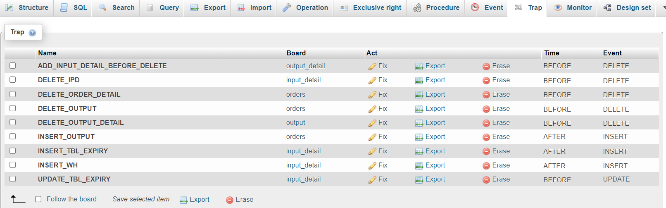

* 1. **Import Project into Eclipse IDE**
* You open Eclipse IDE then create new JavaFX Project and attach the path to the file to open file Project_QLST:

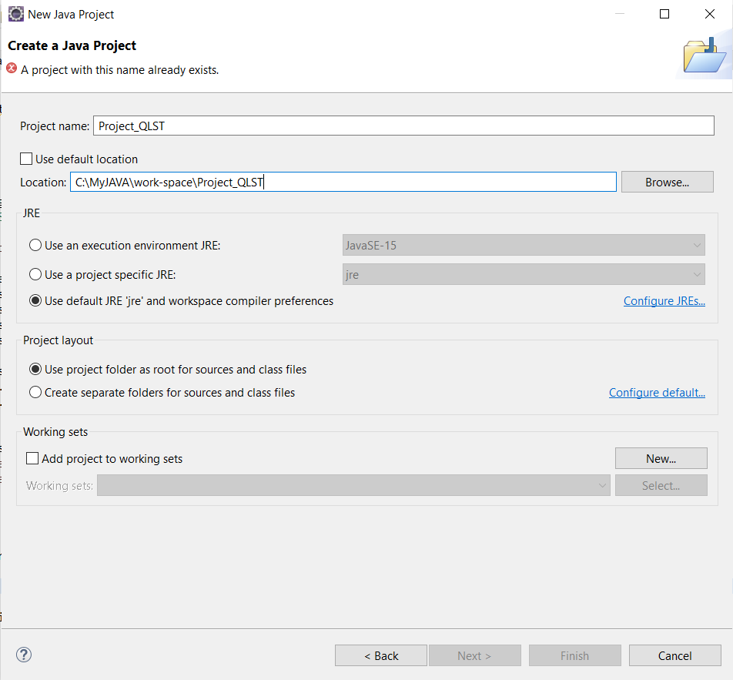

* If you see similar images below, it means you have successfully imported :

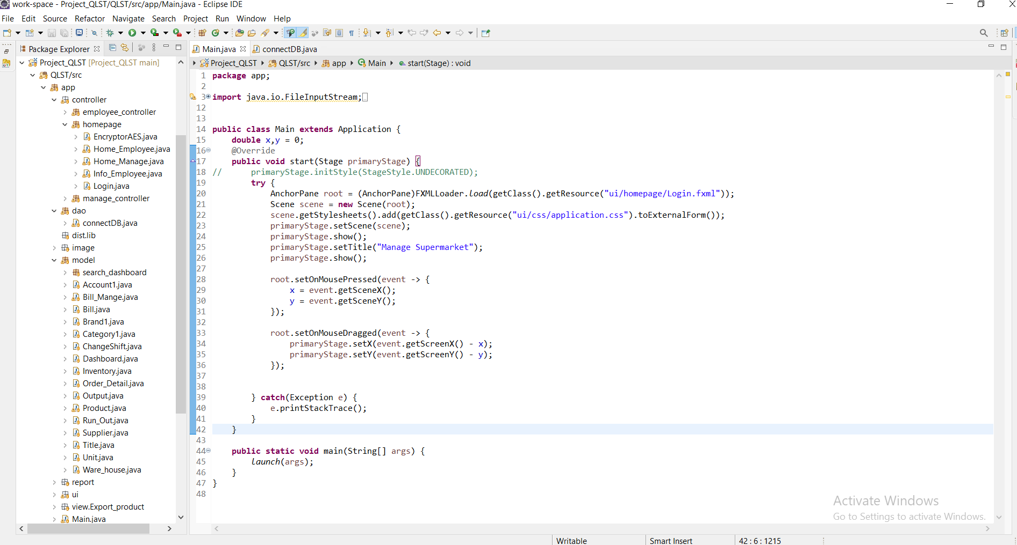

* This is the design table of the keys in the database :

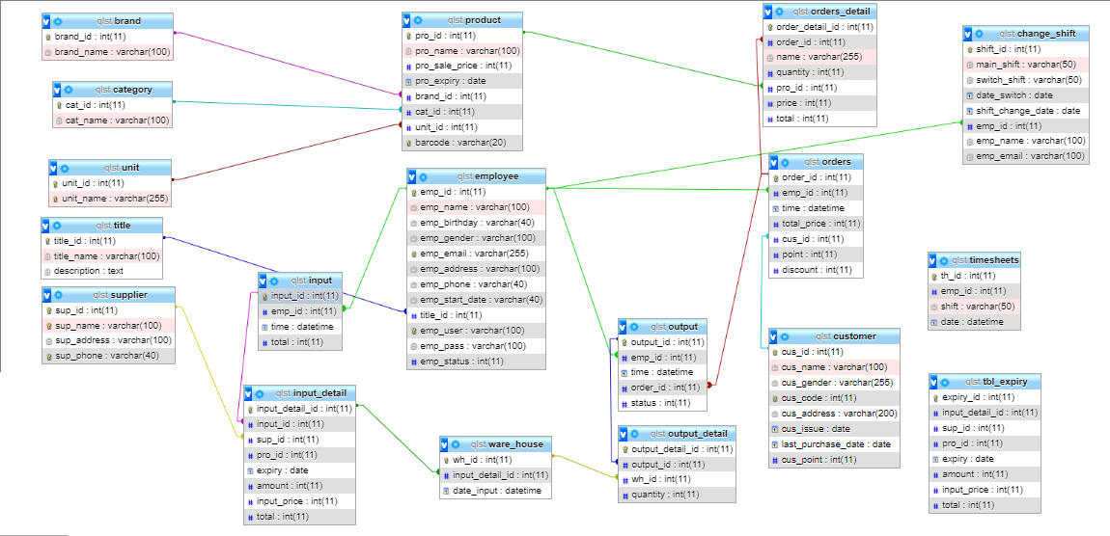

* 1. **Run Project Java Application (Manager Section).**
  + Double Click on Main.java file to open the source code ==> right click to go to Run as ==> Click on 1 Java Application to open it.

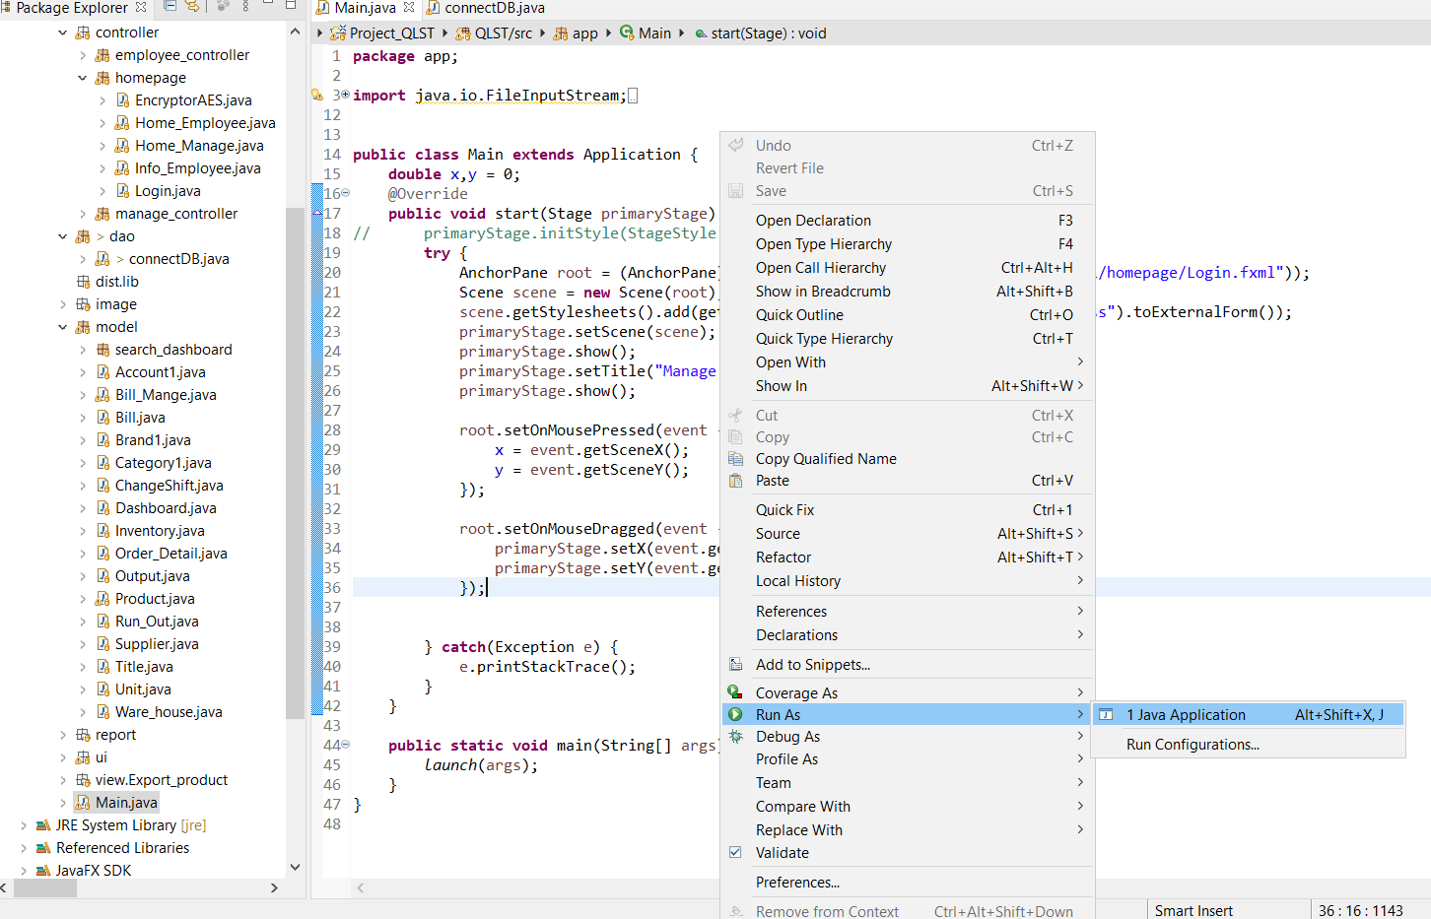

There are 2 main parts: the management part and the employee part.

First, you need to access the Management section to manage the data, so you have to log in to the management section.

The employee part I will introduce later.

**Account Manager:**

Username: a

Password: 1

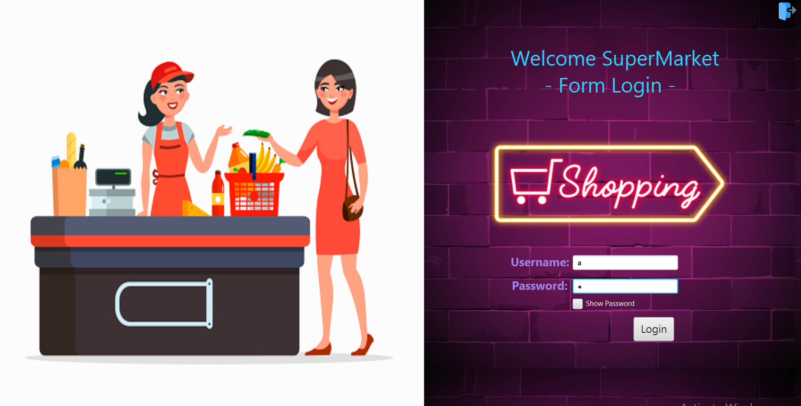

Enter your username and password, click Login button to go to Manager section.

This is the management section, you can check and manage the detailed data of employees, products, suppliers, invoices, categories, brands, year charts , ware house, expiry.

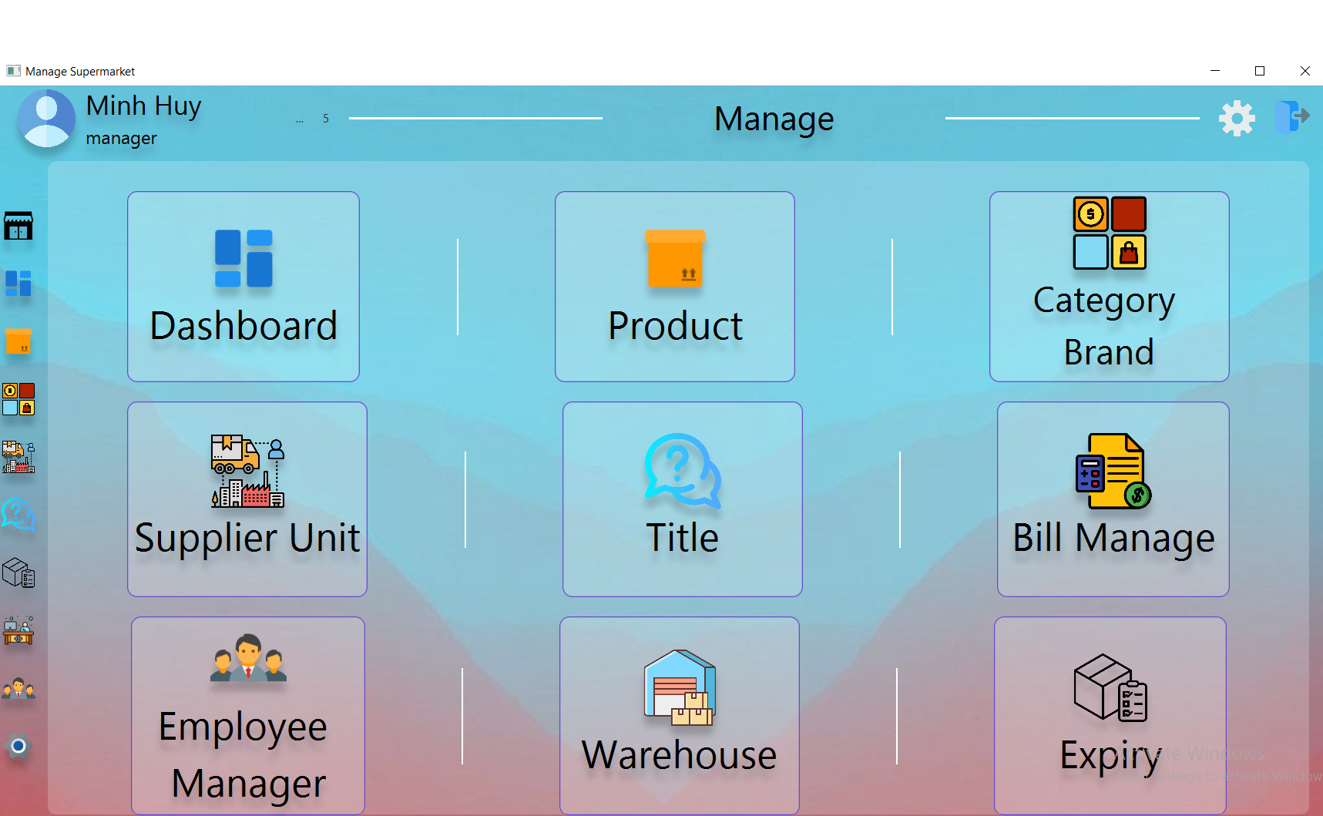

### You can go to the gear section to change your information as well as your password.

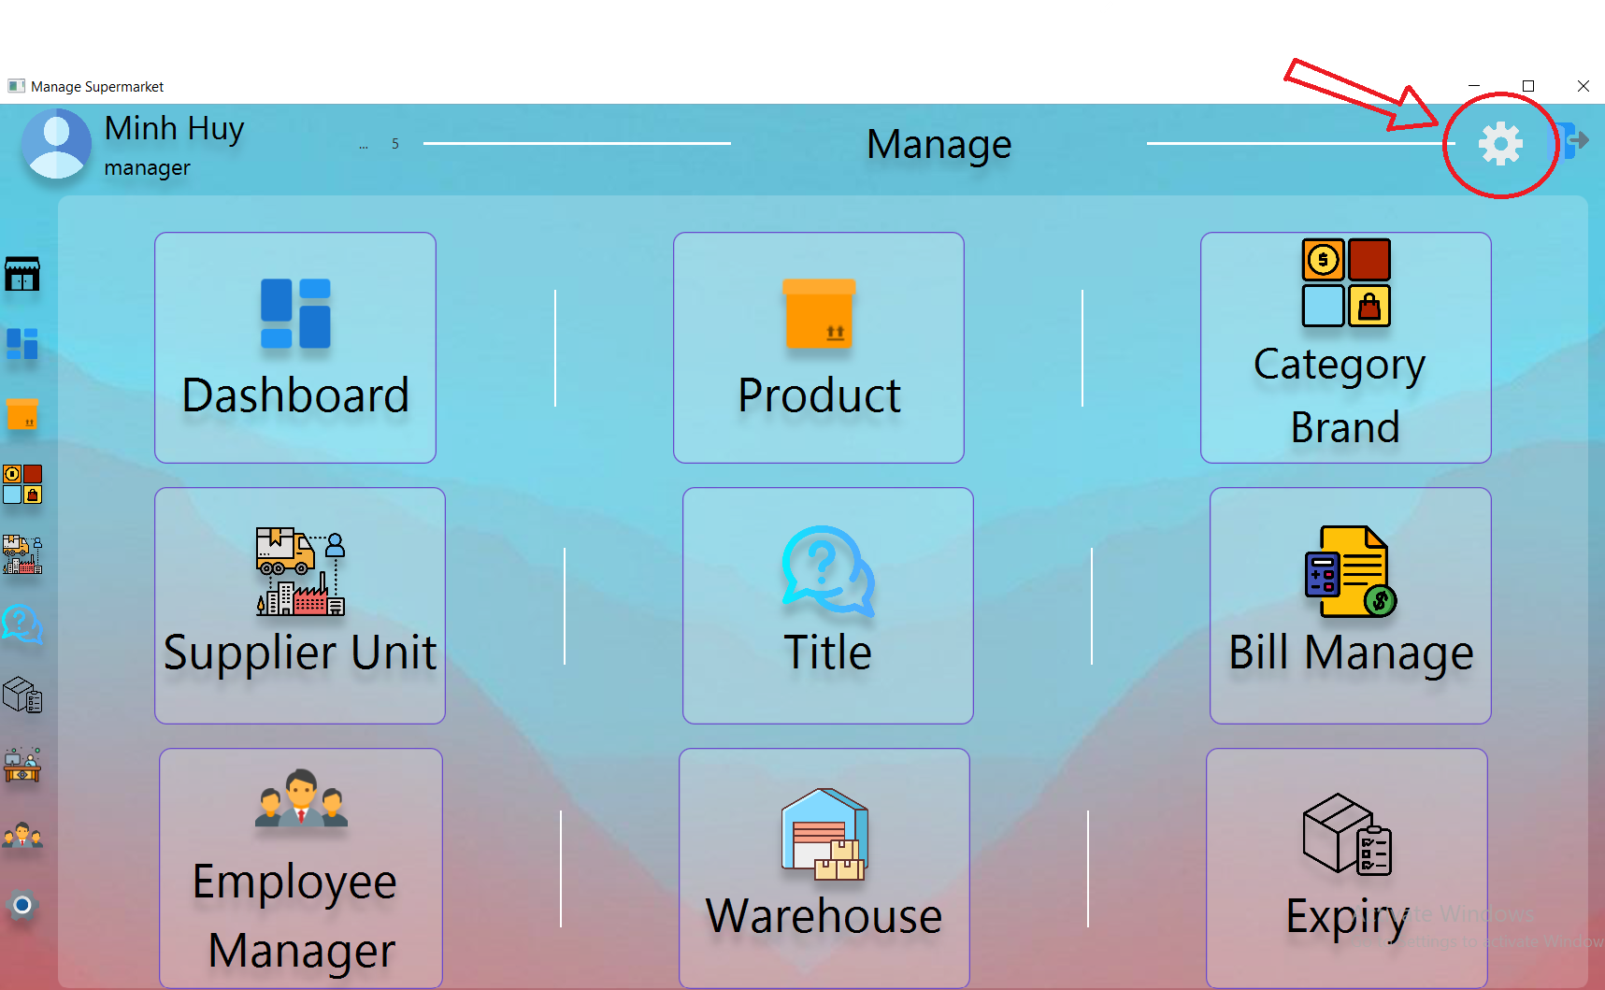

### 

Do not click on the exit door image because it will completely exit to the first login section.

If you want to return to the previous management, click on the word Manage above (The employee section is also Employee).

### A. Dashboarch:

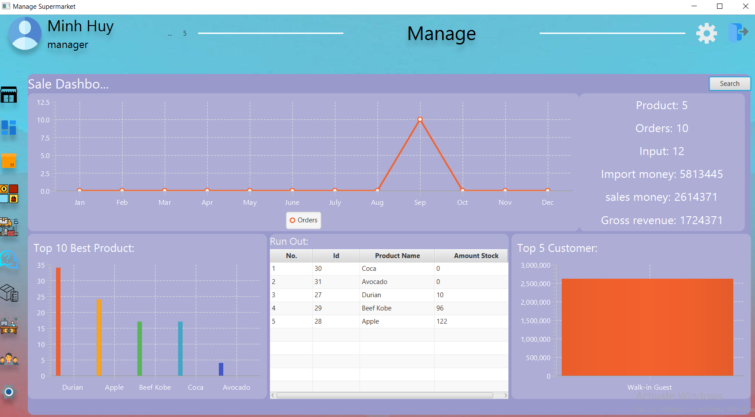

You can view graphs like sales for the year with products, invoices, Cash in, sales proceeds, total sales .

The chart of 10 best-selling products, the products that are almost out of stock and finally the chart of the 5 most potential customers.

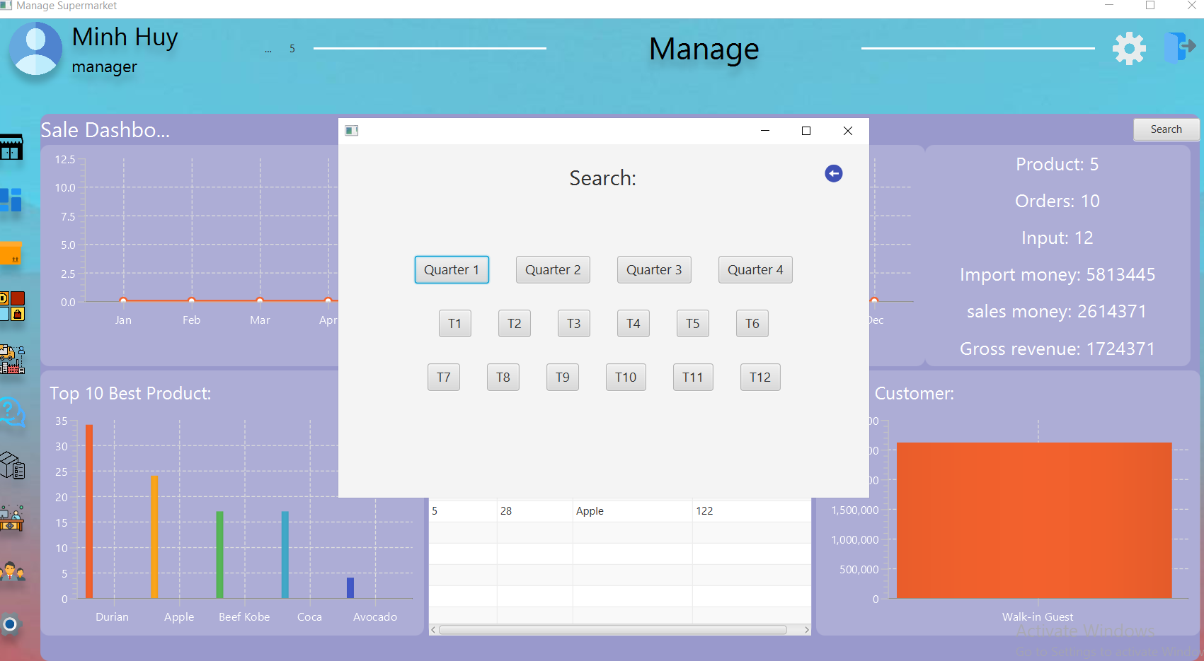

You can view the revenue by quarter or month.

### B. Product :

You can see the detailed information of the products being sold including: **barcode , Product name , Price , expiry.**

Add new products, change product information or delete products .

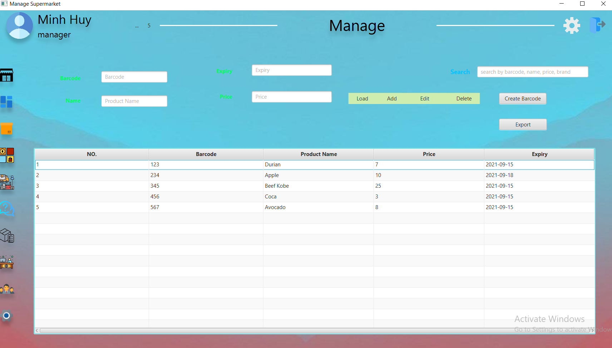

### C. Category and Brand :

This section manages the categories and brands included in the supermaket, you can also add, edit or delete categories and brands.

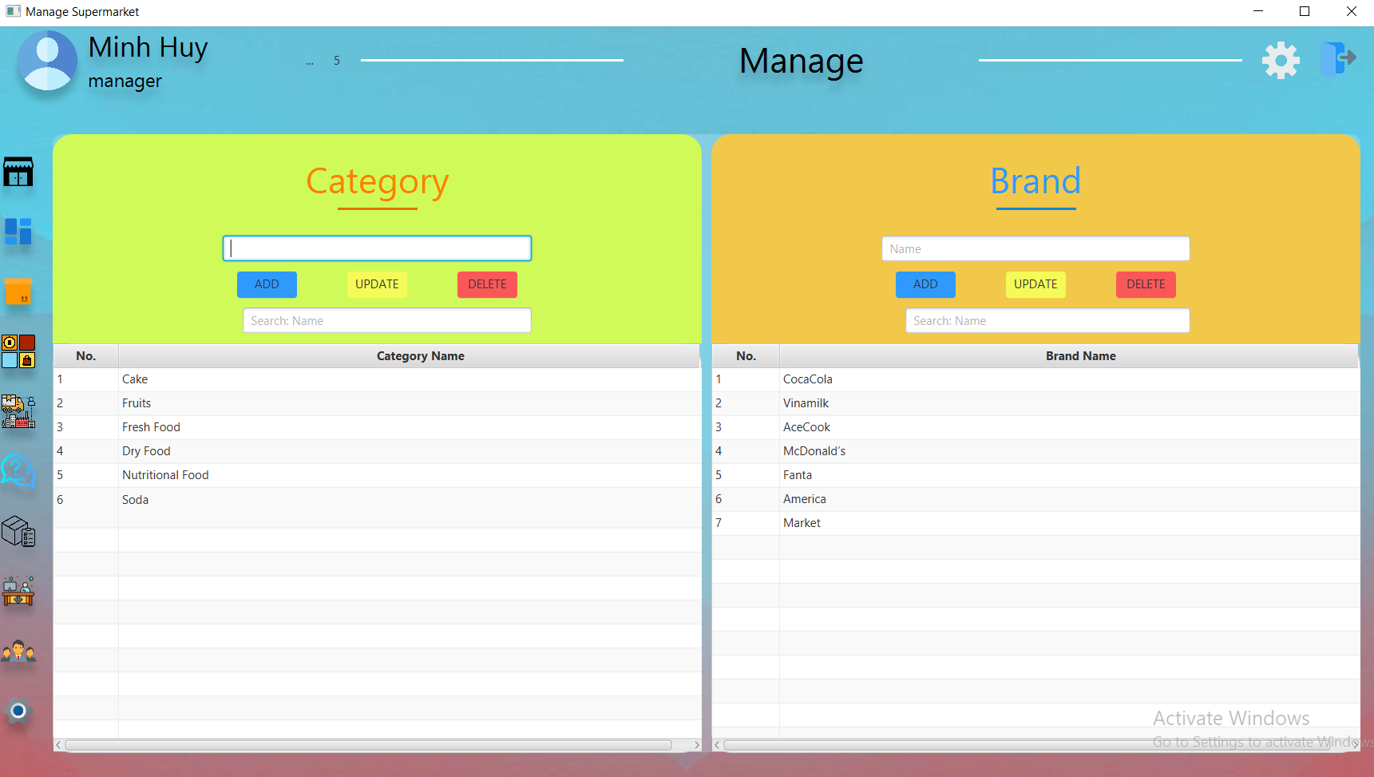

### D. Supplier and Unit :

Same as category and brand:

This section manages the supplier and unit included in the supermaket, you can also add, edit or delete supplier and unit.

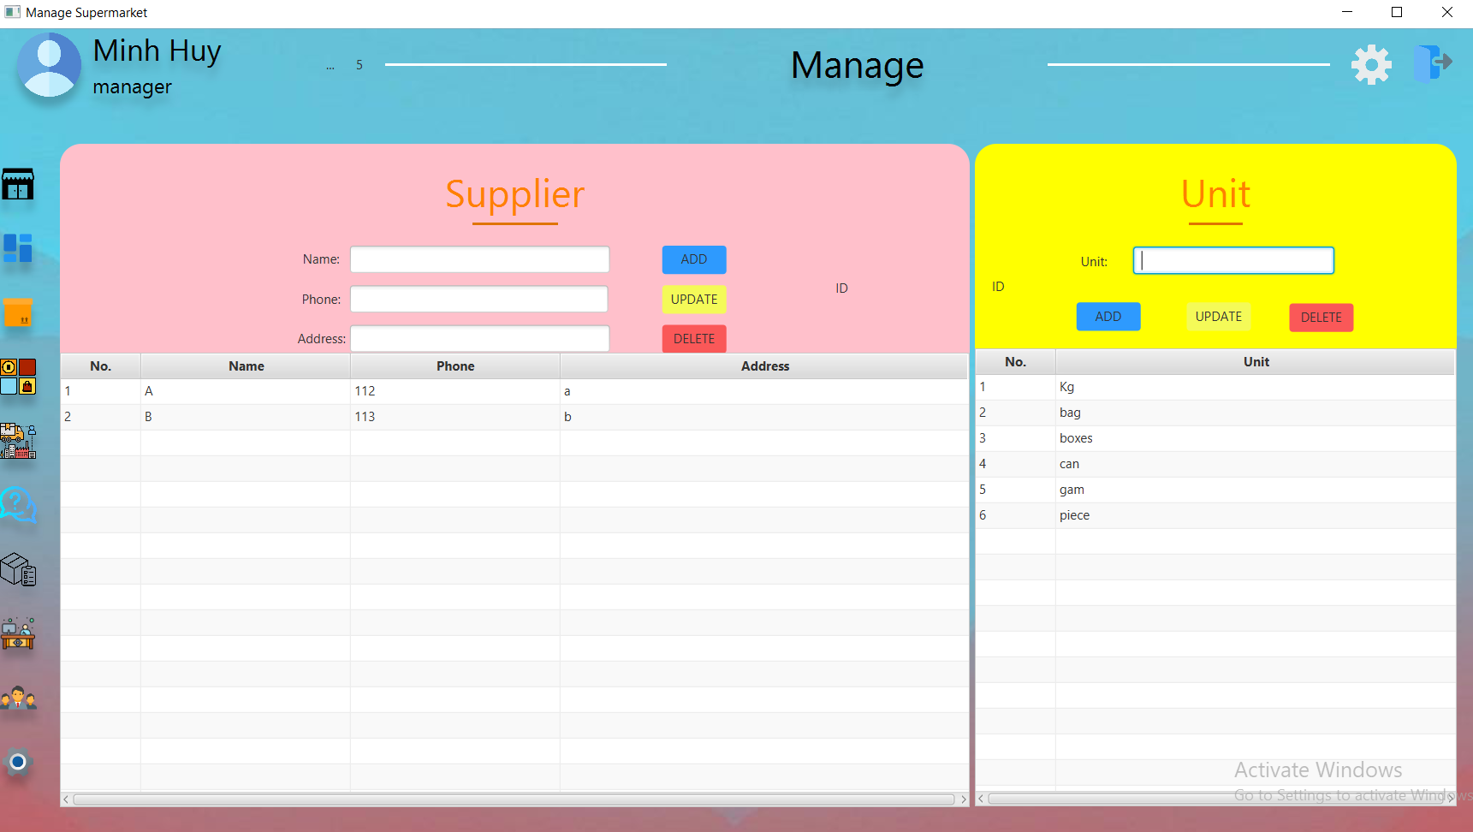

### E. Title :

The positions of the employees are all saved in this , the manager can add new positions if available or needed , add content or job description of that position .

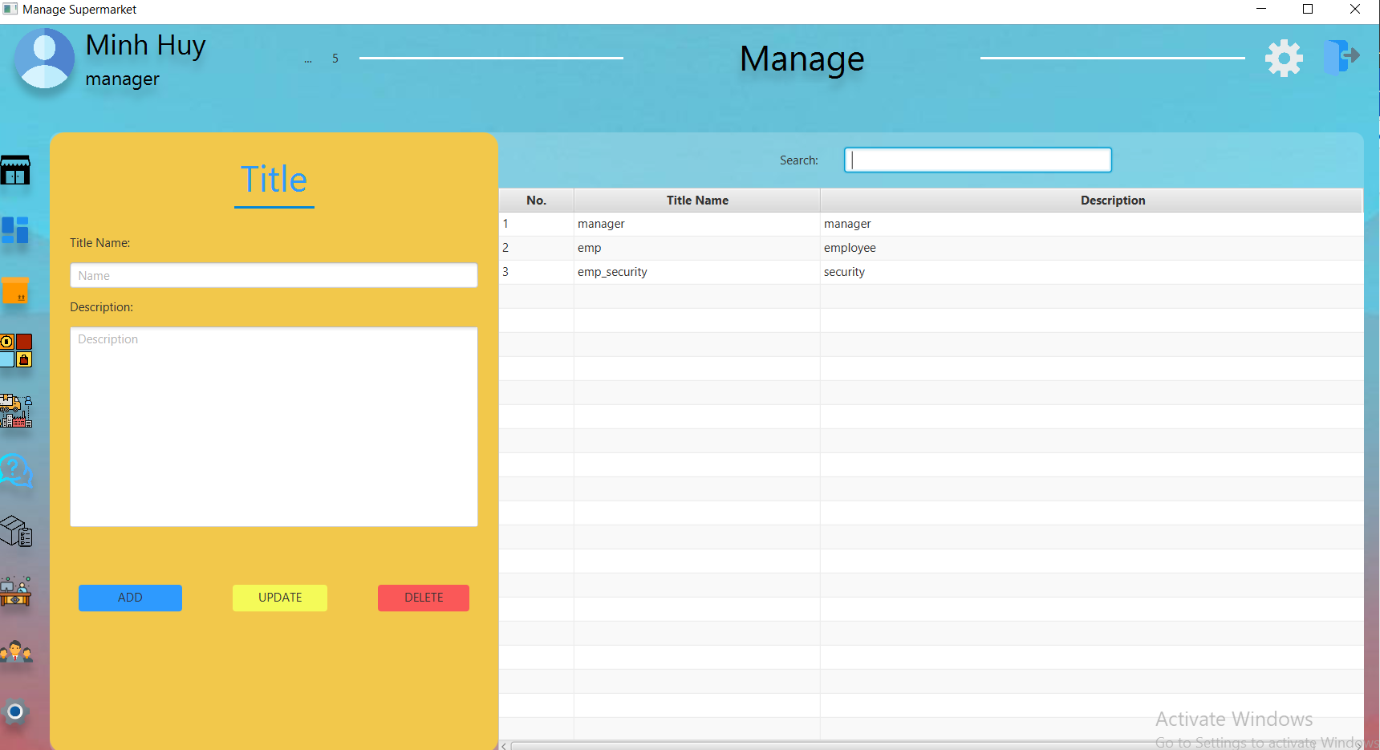

### F. Bill Manage :

This is the part of managing the created invoice, when you select an invoice (on the right panel), it will display detailed information, products included in that invoice (on the left panel).

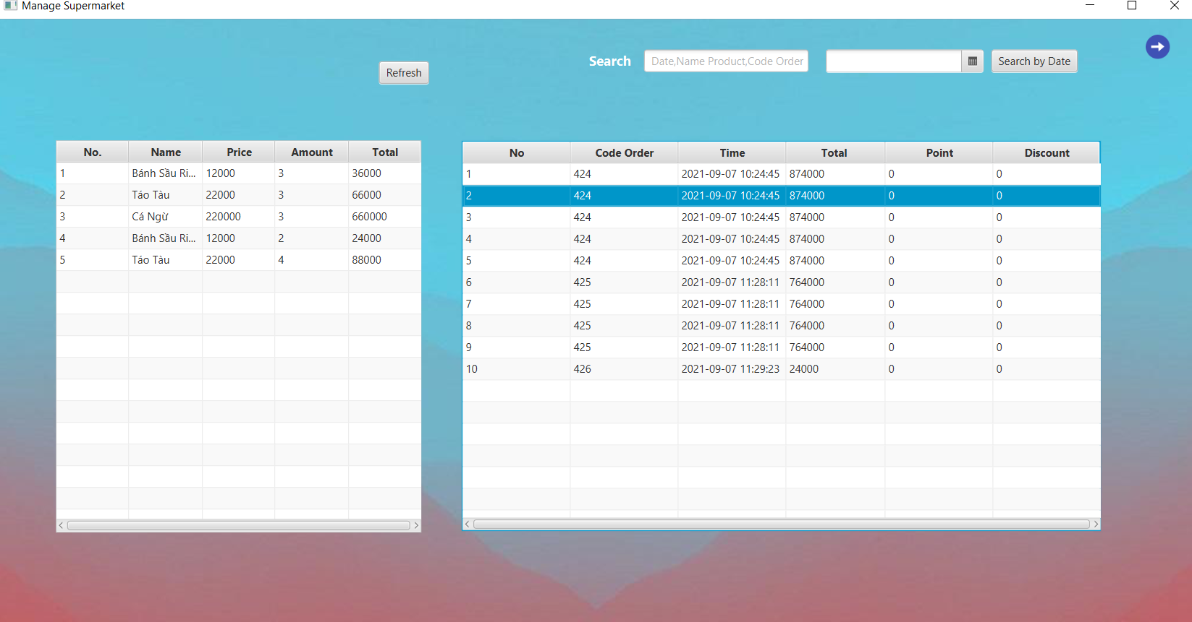

### F. Employee Manager:

You can manage all the Accounts included in the software , new accounts , old accounts.

Can view the status of active or inactive accounts , add , edit , delete accounts in the table .

When adding a new account, you are required to enter all the displayed information, otherwise it will not be possible to add.

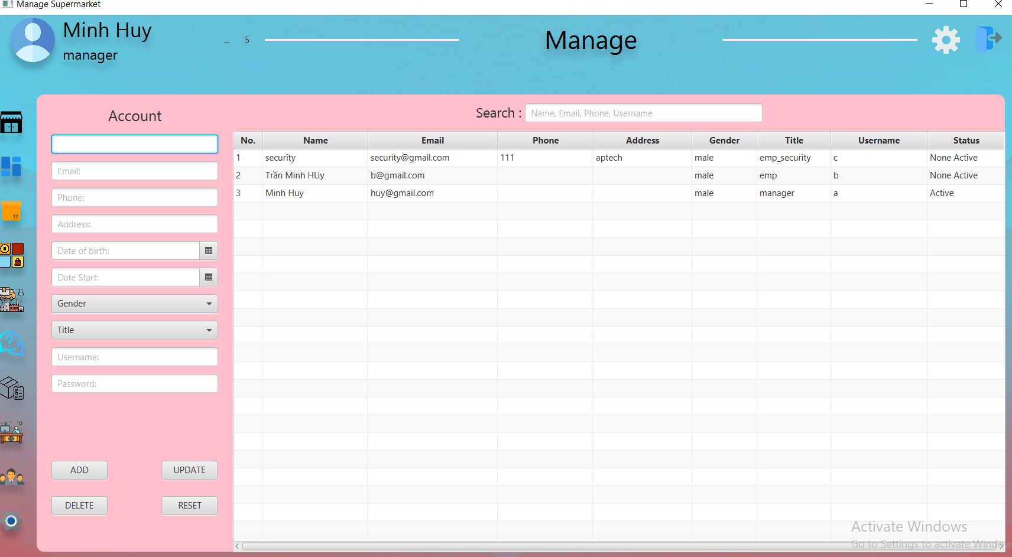

When you have enough information and successfully added, you will just add 1 data to the table and at the same time will send to the gmail of that account (employee) the necessary information such as starting date, working hours, name of the account. account and password to login.

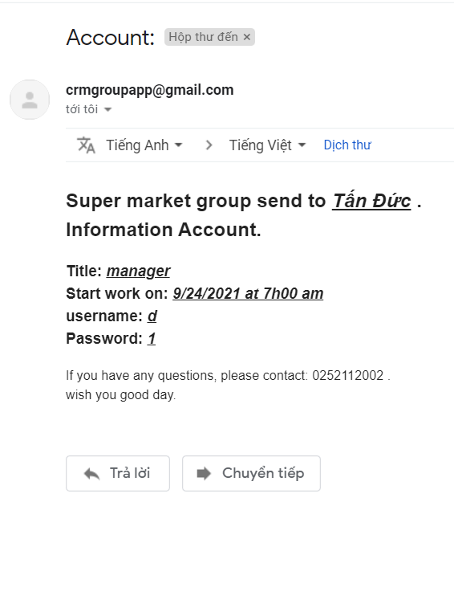

### G. Ware house:

* You can see all product information in ware house like : Name , Supplier name , amount , price , date input , date expiry and you can delete that product only when it has not been billed yet and new product is added.

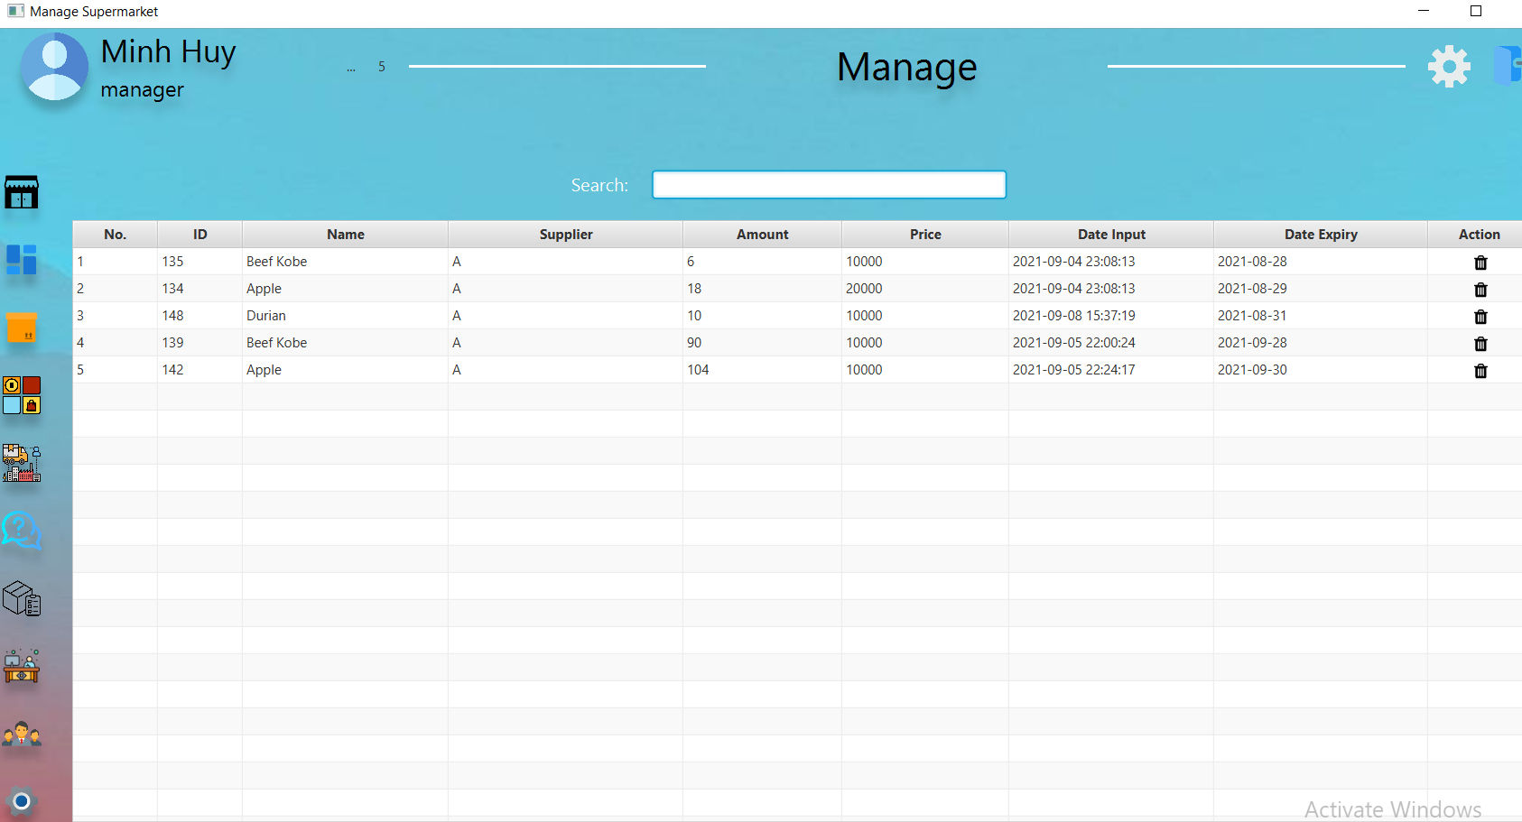

➔Note: A program has only two section!

### H. Expity:

When you have deleted the expired products on the warehouse table, the next place to store those products is the expired table, all of them will go to this table.

If you want to search, you can search by the Id of the expiration table or the name of the product supplier.

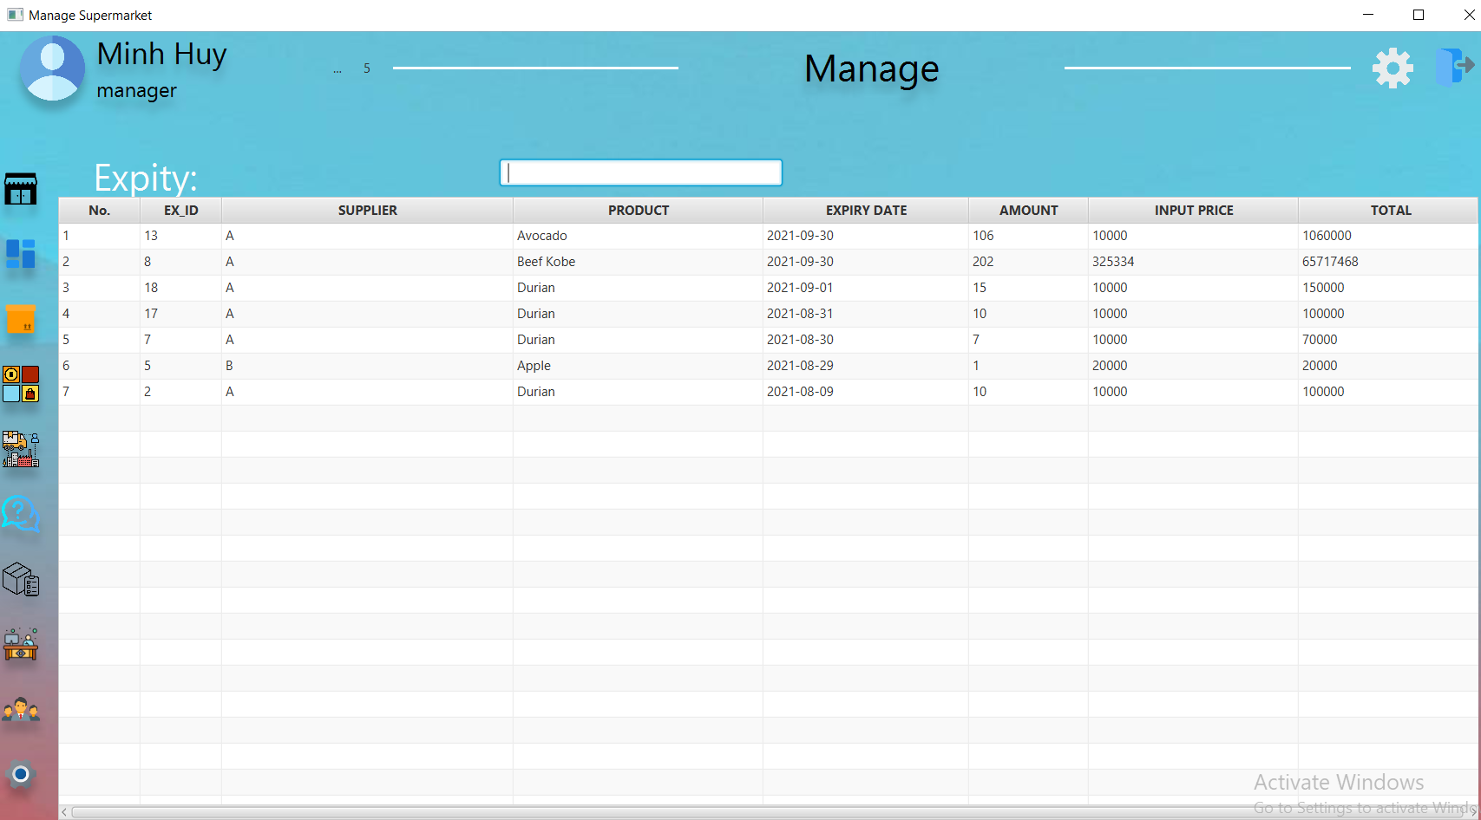

➔ And that's all for the management part, now let's go to the employee part.

➔ Please go back to the login page and enter your employee account

**Account Employee :**

Username: b

Password: 1

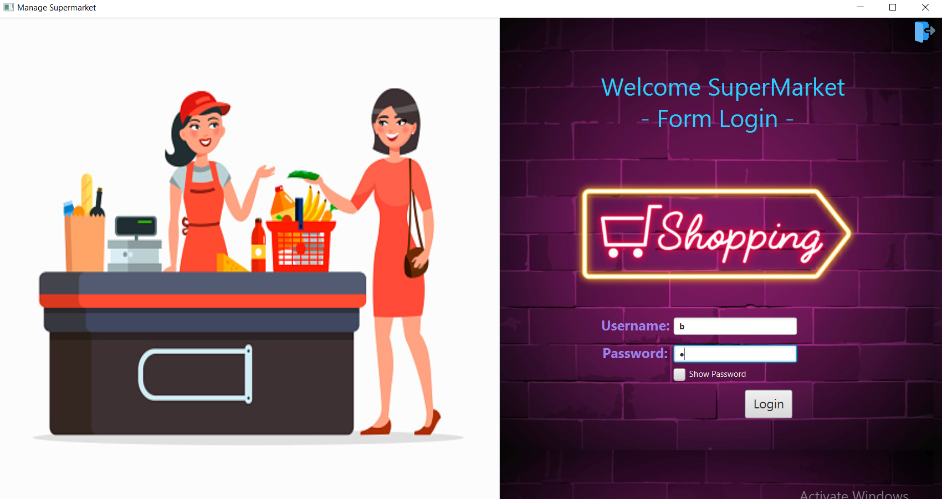

* This is the Employee section, you can check and use the detailed data of Bill Fee, Inventory , Bill Manage , Change Shift , Roll Call .

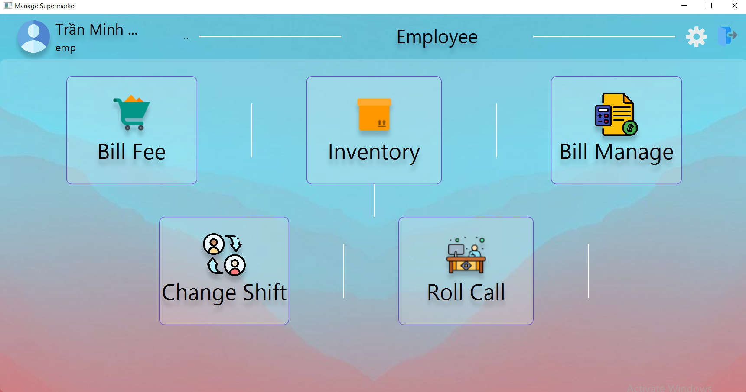

### **1. Bill Fee :**

* Once a customer has a supermarket loyalty card, the salesperson can scan it to get the code and customer information in the card (can be entered in the Customer's code section).
* If that customer does not have a supermarket loyalty card and wants to register for a loyalty card, he can click the Register Customer button.

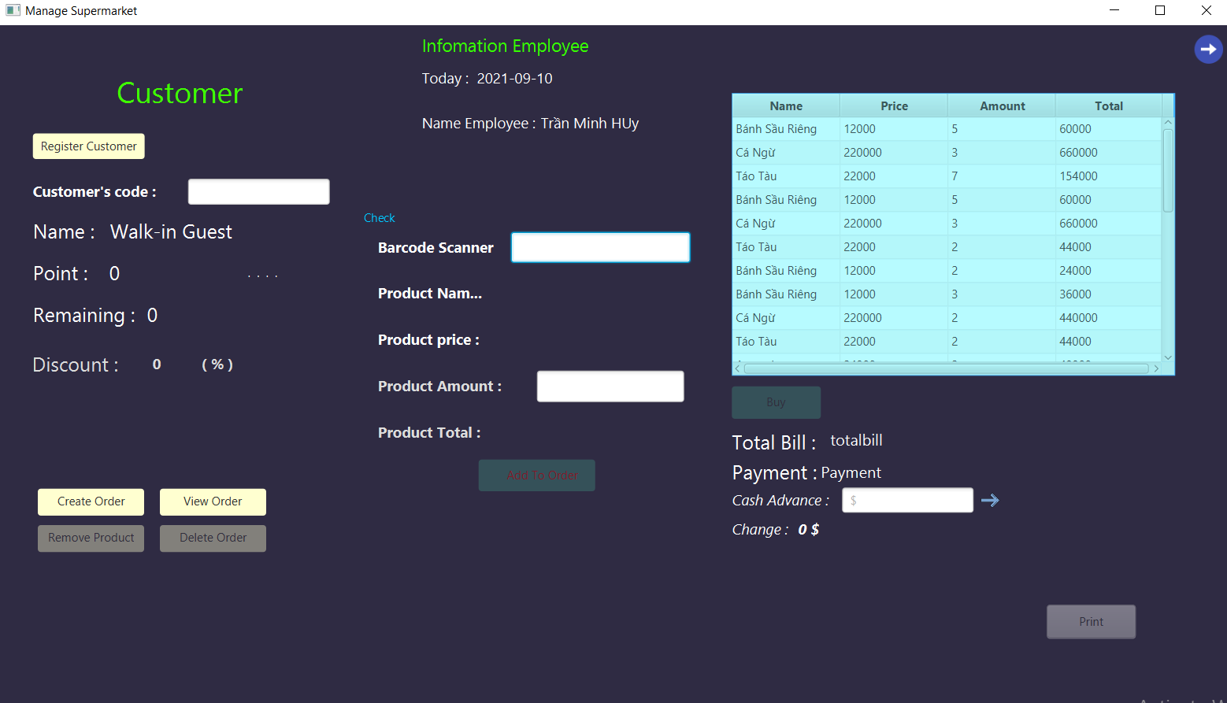

* If that customer's loyalty card has more than 1000 points, that customer will get a percentage discount .

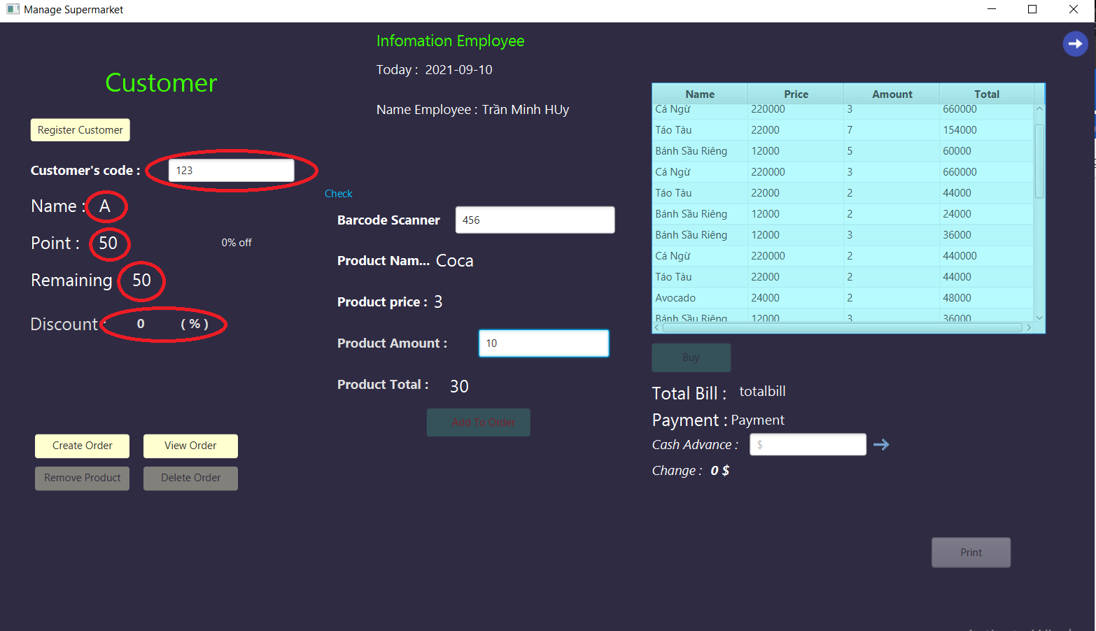

If the customer does not want to accumulate points or does not have a card and wants to buy directly, the staff can click Create order to create a separate invoice to invoice without accumulating points to reduce the price.

You can delete the order to.

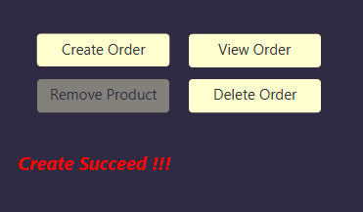

Create a new invoice and buy .

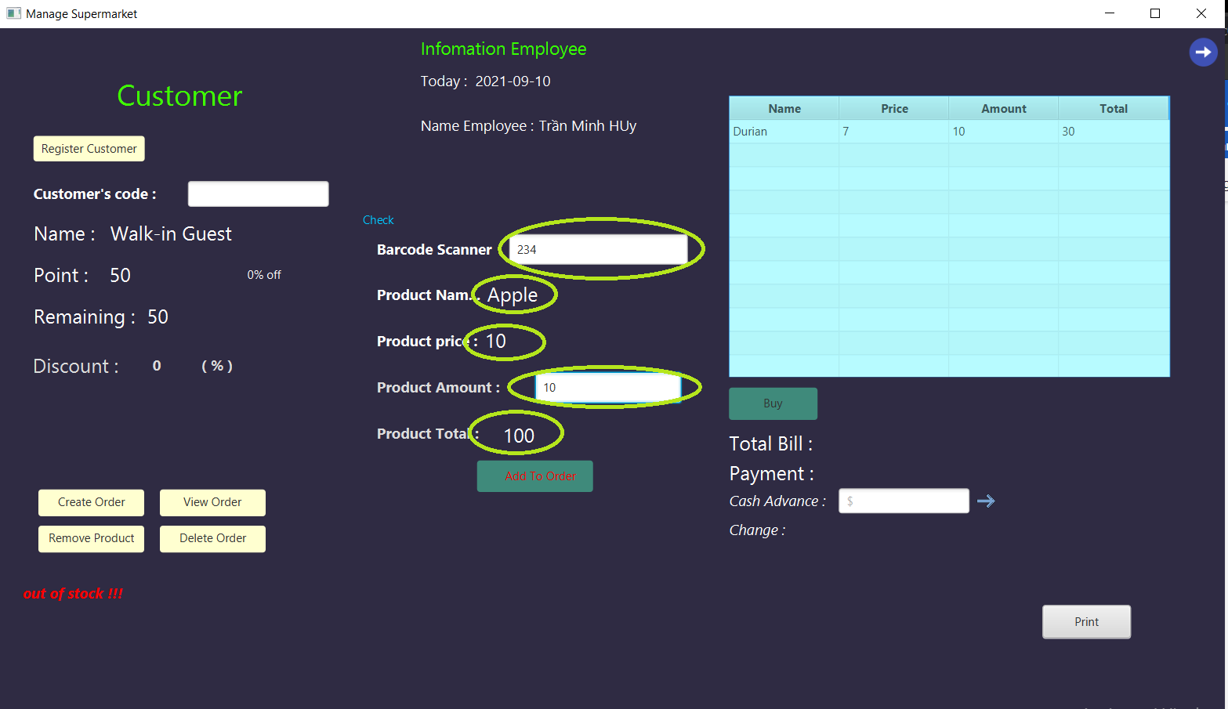

* After receiving the customer's money, you can enter the amount to show the amount to change.

- You can press the Print button so that customers can get the invoice of the total product they buy

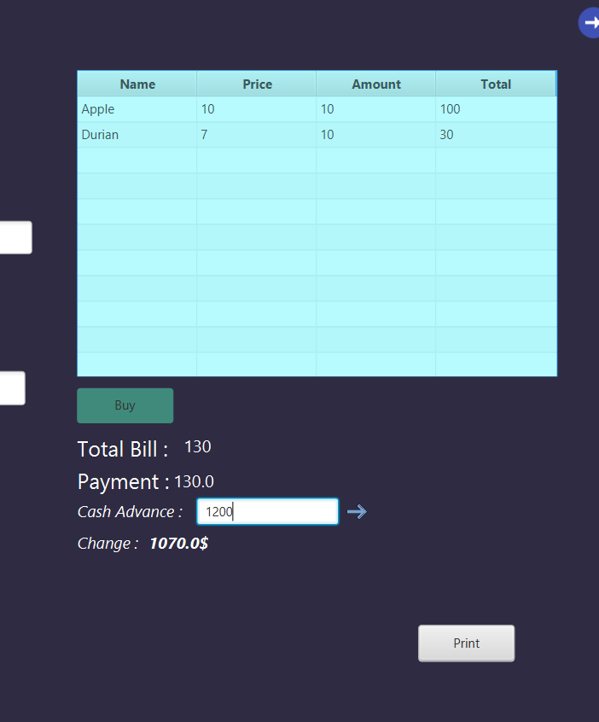

### **2. Inventory :**

- This is the inventory section, you can see the total number of products in the inventory, the warehouse id, the input detail id, the product name, the quantity, the input price and the import date .

* You can search for product name and date input.

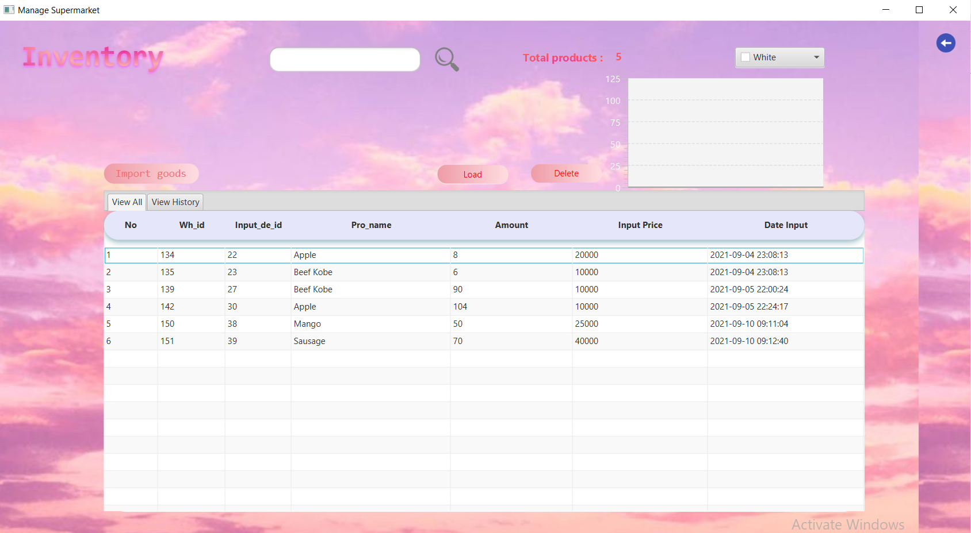

Employees have the right to set receipt .

When employee click on the button Import goods , this receipt will appear .

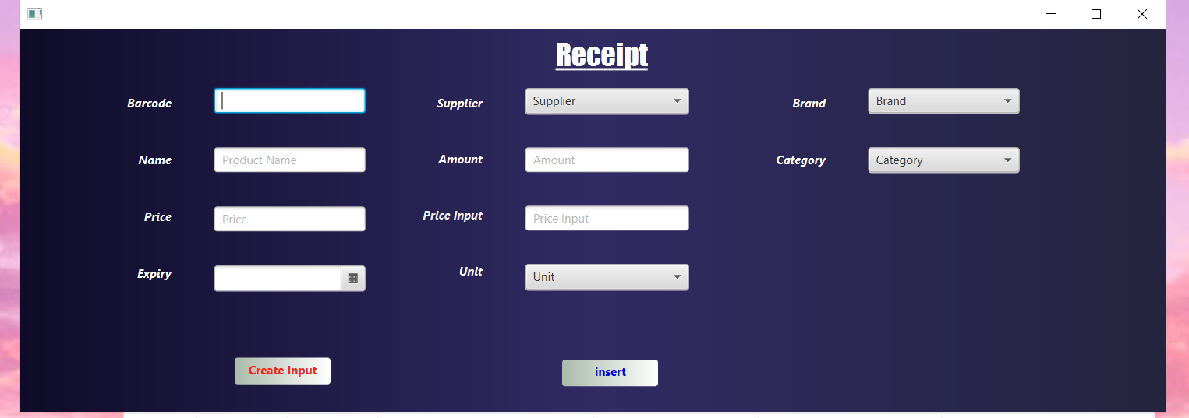

Employee can create a new input .

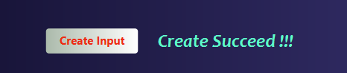

Once a new input has been created, the employee can create a detailed entry form and create a new product in the product table, like so.

### **3. Bill Manage :**

Similar to the management section, employees can also view the invoices for the day and details about that invoice.



### **4. Change Shift :**

You can view information about changing shifts and changing shift dates between employees. From there, you can better capture the shifts and change shifts with each other .

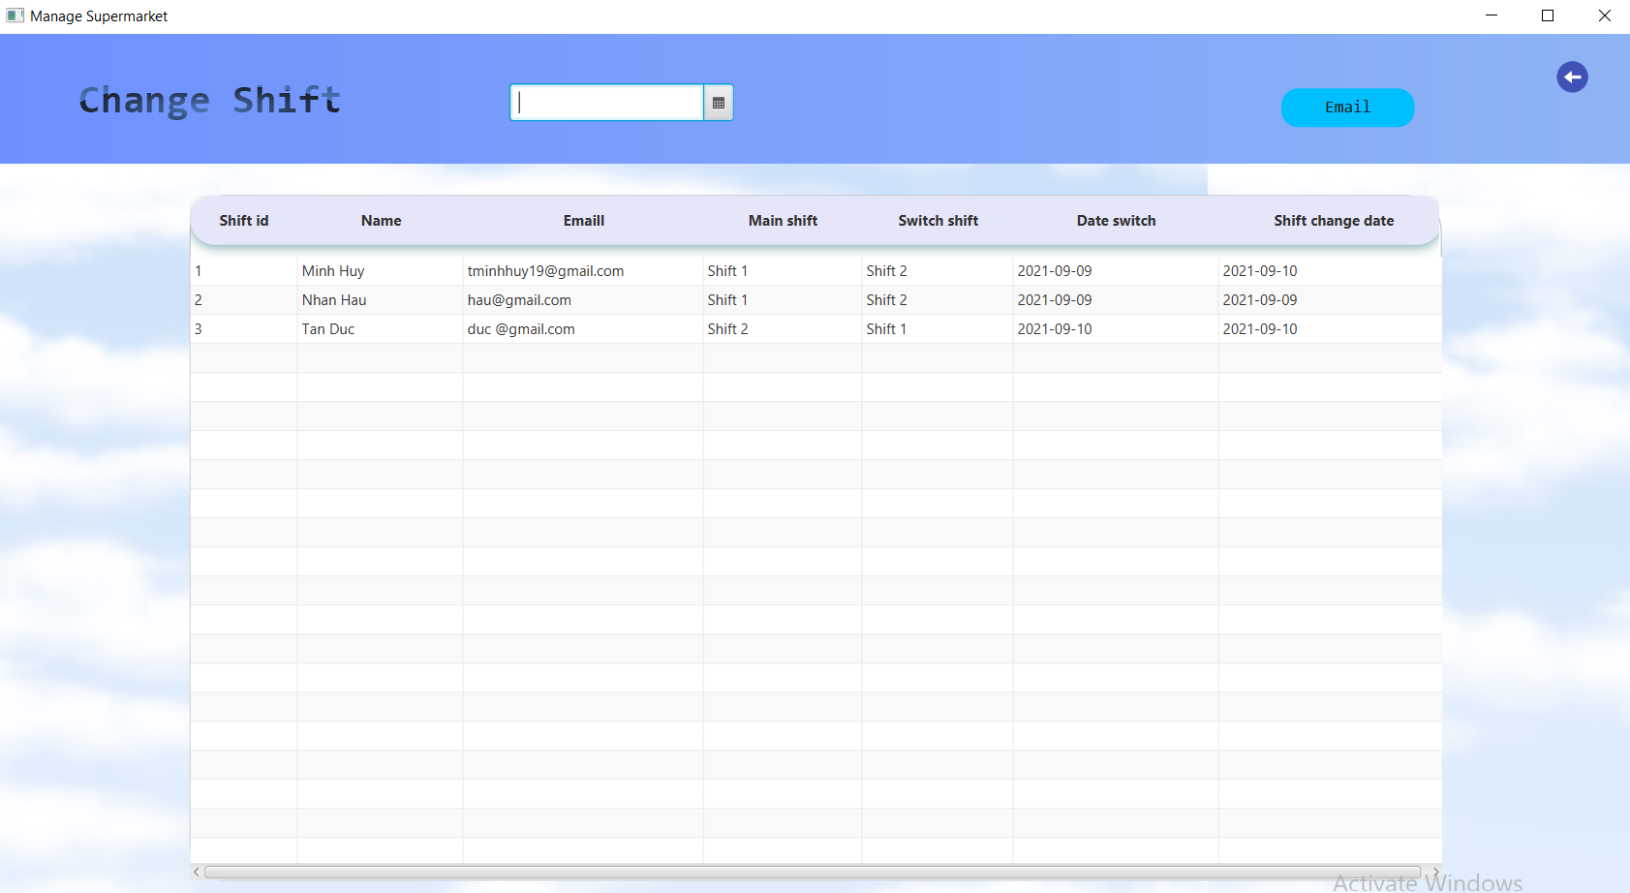

Click the email button to email the shift change to another employee.

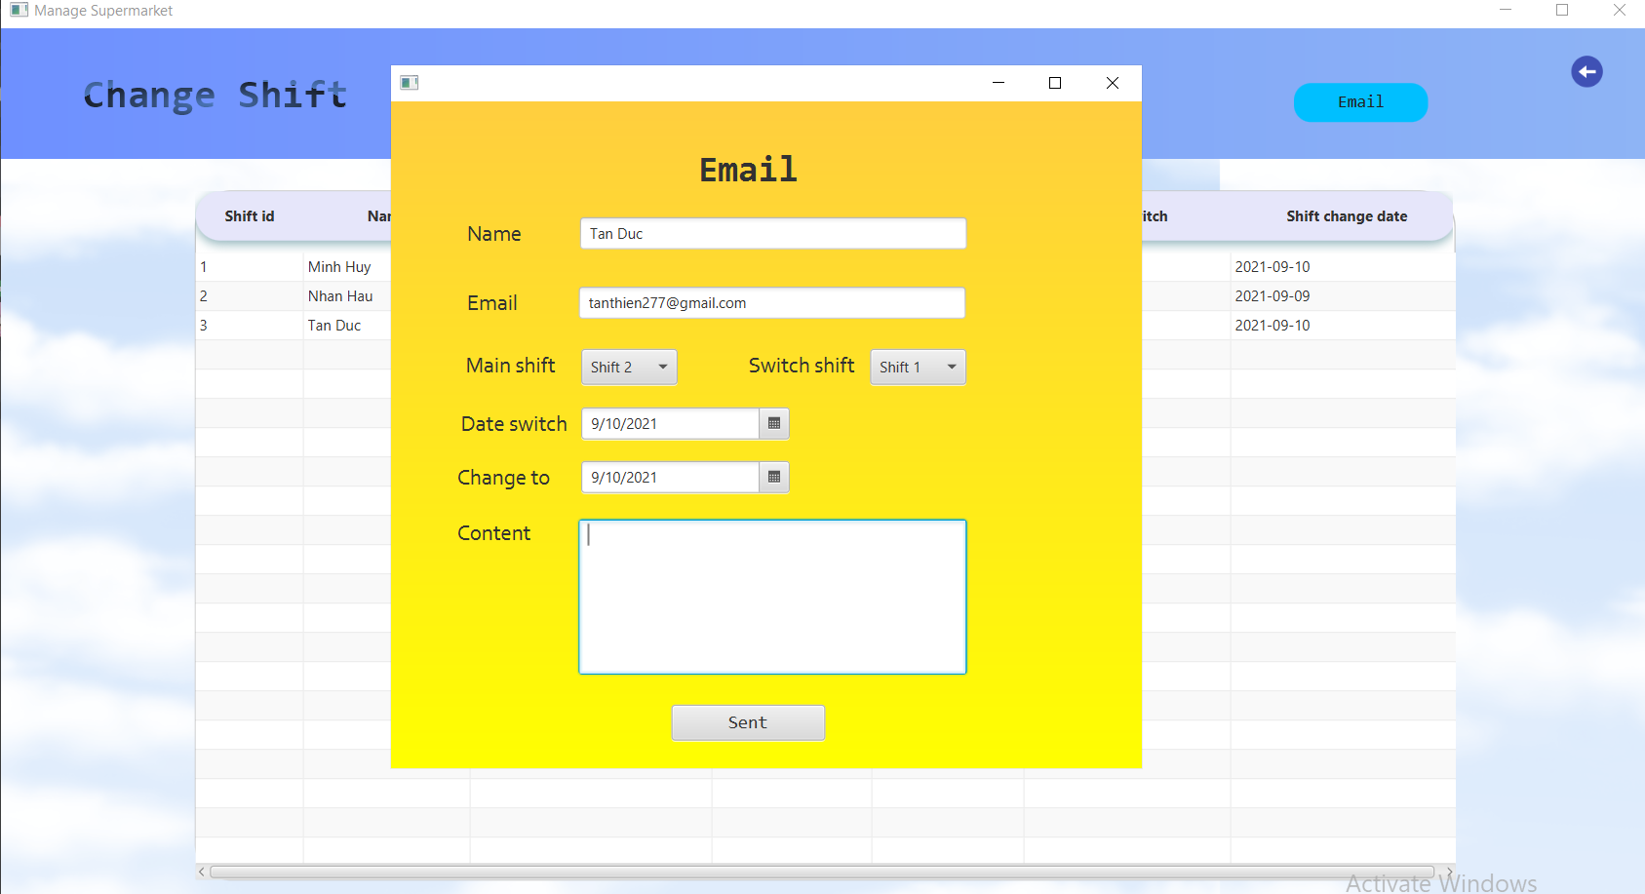

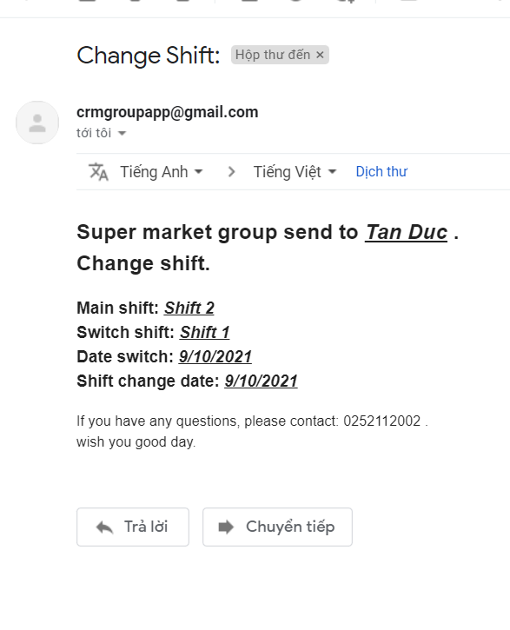

### **5. Roll Call :**

And finally the roll call part.

When employees start their shift, they can go to the roll call section to take attendance for their shift

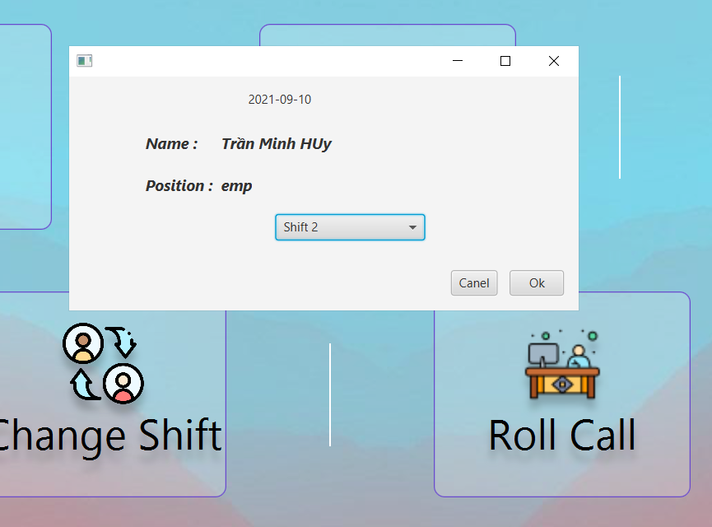

➔ That's all our team did.

➔ This is our first time doing a java project, although there are many shortcomings, but our team will definitely try harder, make more efforts and achieve more success in the future.

**6.Database.**

ER Diagram:



*Prepared By: Duong Nguyen Tan Duc.*

*Approved By (Trainer): Mr. Khiem Bui.*